2/10/2015
BNSF Railroad
Sean Ward/ISD

WBT Training Course: Operations Testing Data Entry [12 Slides]
Terminal Objectives
A Terminal Objective is a statement of a lasting and intrinsically useful skill which the learner must have acquired at the end of a particular learning activity. This skill may be described in general or specific terms; in other words, a learner may have general terminal objectives and specific terminal objectives.
Terminal objectives for this course:
- Learner will understand the importance of accurate reporting of field testing events into the BNSF mainframe system.
- Learner will be able to locate and identify unique data entry fields used in operations testing reporting for BNSF employees tested on a BNSF subdivision.
- Learner will be able to complete the required fields and be able to successfully enter and print an operations test.
Intermediate Objectives
An Intermediate Objective is a statement which indicates, within a sequence of various items of learning, an item which the subject must master before the terminal objective is attained. Intermediate objectives may be general or specific but they are used as a means of attaining a terminal objective. They are objectives which apply during learning process.
The student must be capable:
- Of accessing the main screen in the BNSF mainframe system.
- Of reading and validating information in the Broadcast screen.
- Of navigating to the Main Data entry screen.
- Of launching the Help feature.
- Of properly selecting input for the Action, ID, Date, Time, Train, Contact, Subdivision, Test Type, Primary Officer Code, Other, Occupation Code fields.
- Of accurately populating the Global Milepost field.
- Of entering the test number, rule code, rule #, or segment when required.
- Of storing testing information into the computer system.
- Of entering a Lata or LPE address to direct testing data to a printer of choice.
- Of validating the accuracy of the testing information being entered.

Audio Transcript and Slides
Slide 1:
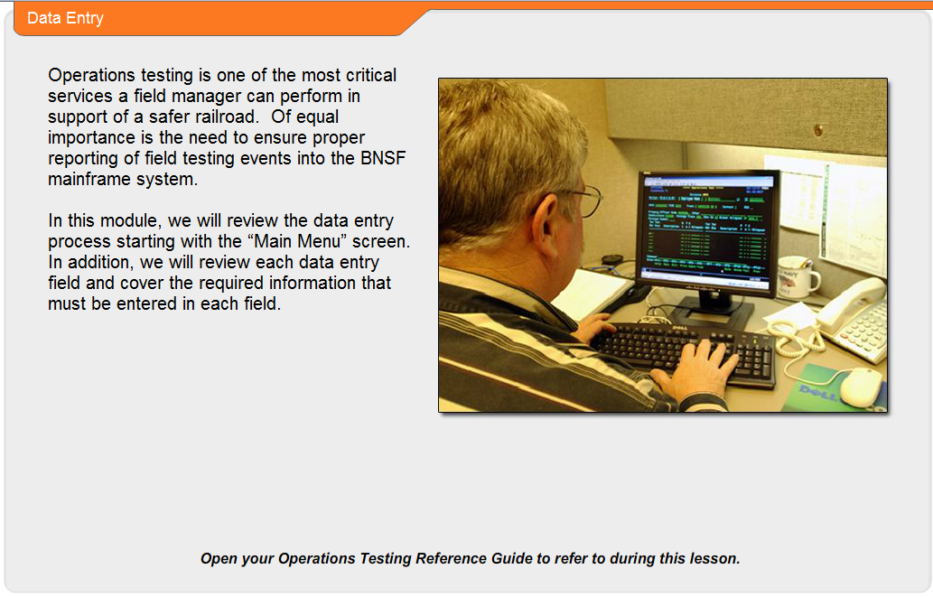
Operations’ testing is one of the most critical services a field manager can perform in support of a safer railroad. Of equal importance is the need to ensure proper reporting of field testing events into the BNSF mainframe system.
In this module, we will review the data entry process, starting with the main menu screen. In addition, we will review each data entry field and cover the required information that must be entered into each field.

Slide 2:
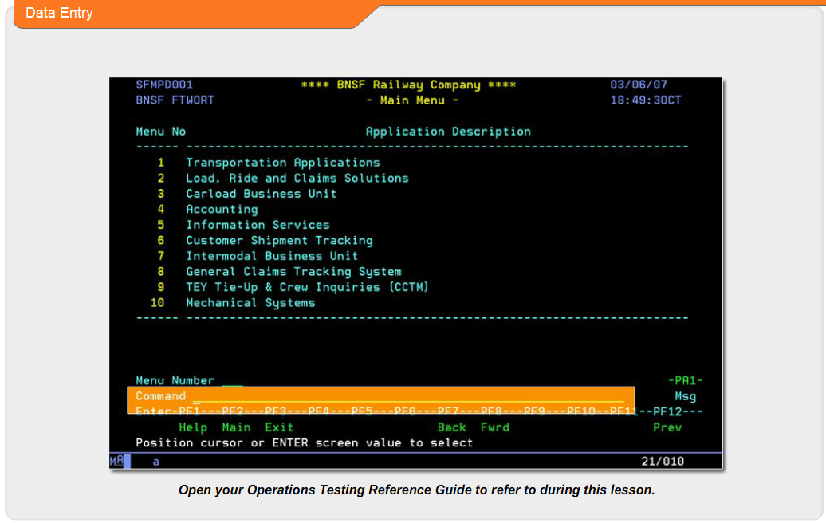
Starting at the main menu screen, go down to the command line and type in the letters, “OPT”.
You do not need to worry about case sensitivity when entering data into this program. Once you have entered the command, OPT, press the Enter key.

Slide 3:
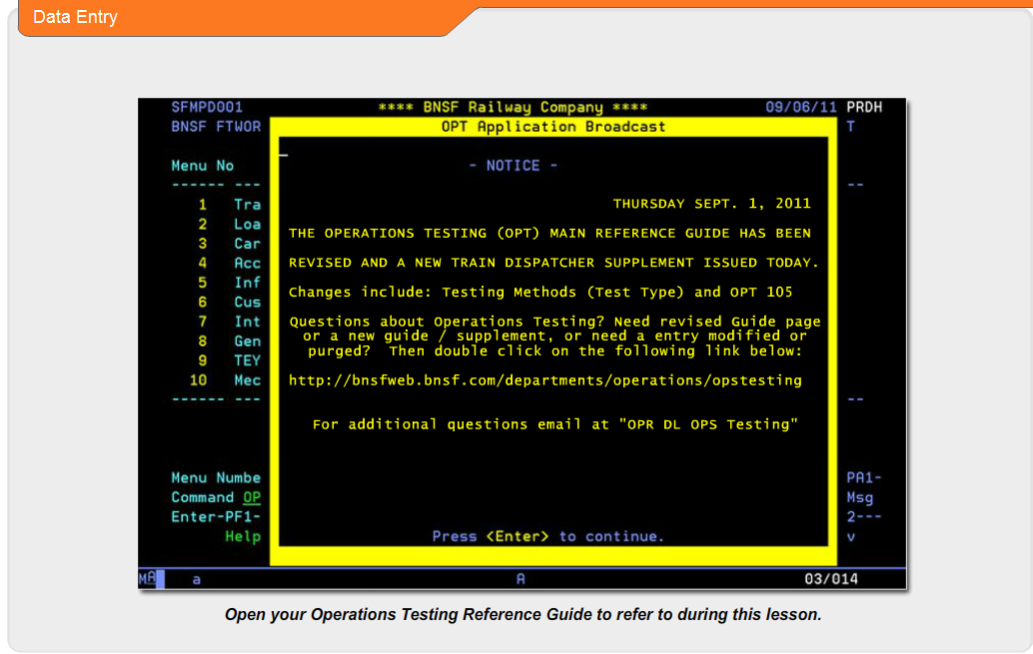
Displayed on the next screen, you will see a system broadcast screen. This screen is referred to as the OPT Application Broadcast screen. This screen will display important information regarding operations testing that needs to be distributed system-wide.
For your ease in identifying new materials, an updated date is provided toward the top of the screen. Please make sure to read the information within the broadcast screen, or at least validate that new information has not been posted since the last time you received the broadcast screen.
Press the Enter key when you are ready to proceed.

Slide 4:
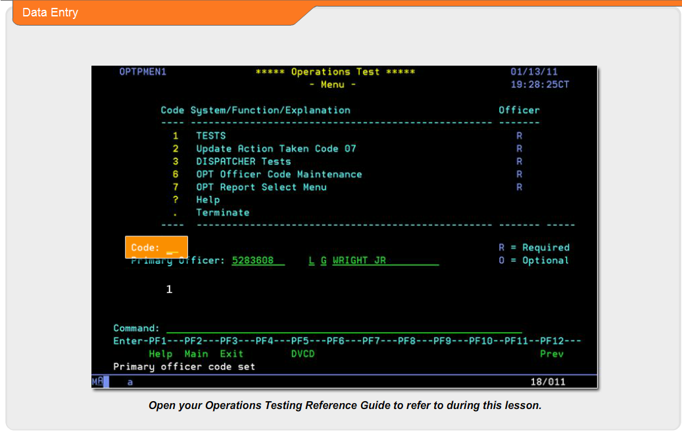
The operations test menu screen contains several options. In this lesson we will use option 1 only. This option will take us to the Main Data entry screen.
In the Code field, we will enter a 1 and press the Enter key.

Slide 5
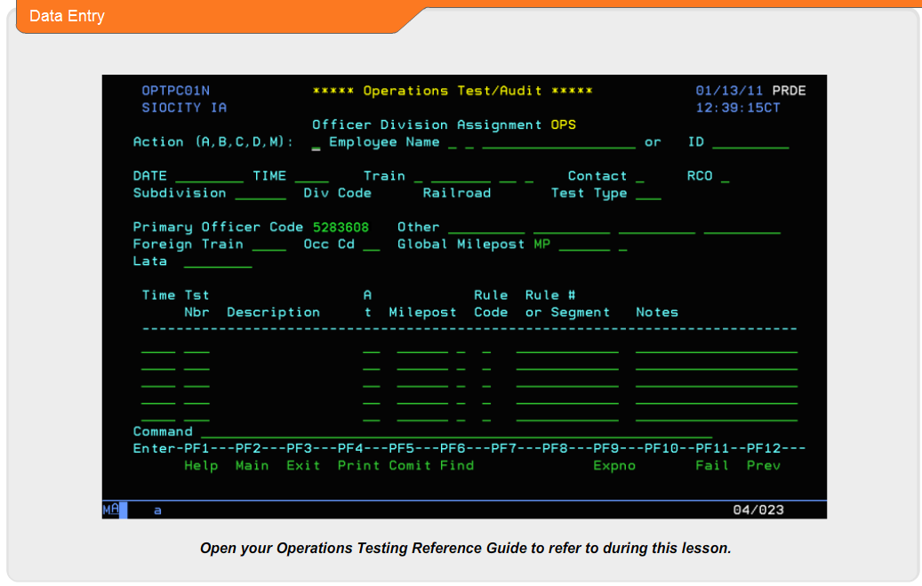
Now that the main data entry screen is available, it is time to look at each input field that makes up the total screen.
One important feature that exists within all TSS mainframe screens is the Help feature.
On any input field, if you are not certain of the data required for the specific field, you can press the F1 key and the Help screen will display pertinent information about the field requirements.
We will review the data entry requirements based on a BNSF employee being tested on a BNSF subdivision.
Testing instructions for entering foreign or contract employees, and foreign testing officers, will be covered in a separate program.

Slide 6:
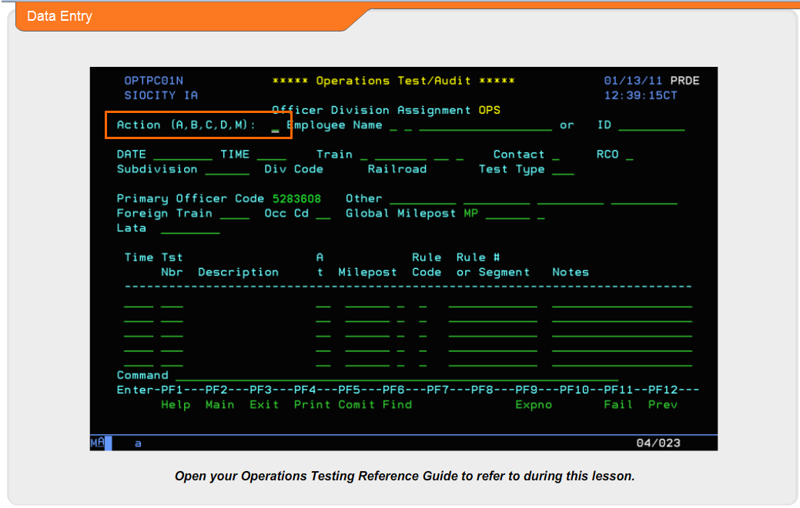
The first field that we will review is the Action field. In this field there are five letter options available. A is for adding data, B is used for browsing, using C will clear entered information on the display screen. The D is used to display information. And finally, M will allow you to modify certain information.
For this example, we will be using the A feature to add testing data.
To maintain the highest level of reporting accuracy the employee number must be used. To enter the employee 7 digit number, you will need to use the ID field.
However, if you do not have the employee’s 7 digit employee number, you will need to enter the employees name including first and middle initials. If the tested employee’s last name is followed by a junior, senior, third, you will want to enter that with the last name. In situations where the employee’s last name is not unique, such as Smith, or Jones, you will be directed to a larger list of names that will allow you to find the correct employee, by employee number, work location, and craft.

Slide 7:
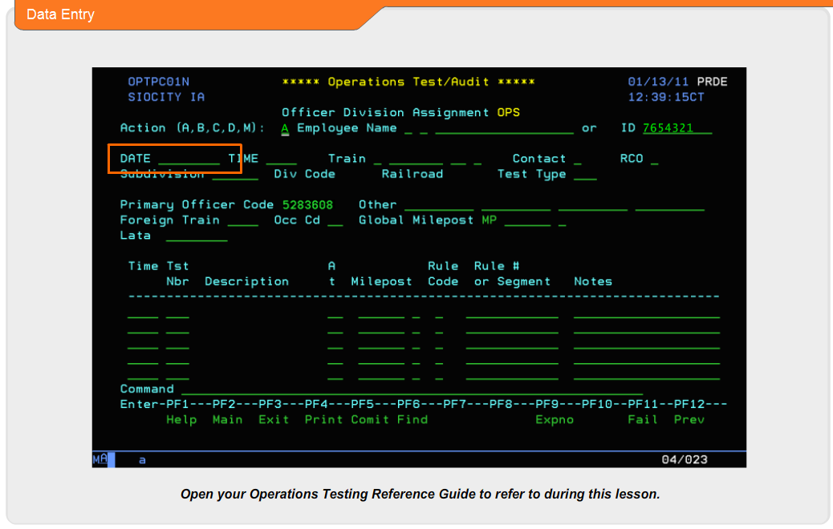
The Date field requires that the date of the test be entered using numeric characters in the format of month, date, and year.
The time of the test must be entered in the Time field. Enter the time in hours and minutes, of the test, using the military time format.
The Train symbol field requires an entry to be made. In cases where the tested employee is not involved with the movement of a train or yard crew, enter None in the second field within the train symbol section. Otherwise, enter the train symbol.
The Contact field is used to indicate whether the tested employee has been contacted by the testing manager. Place a Y in the field when the tested employee has been contacted by the testing manager. If no contact has been made with the employee, place an N in the field.

Slide 8:
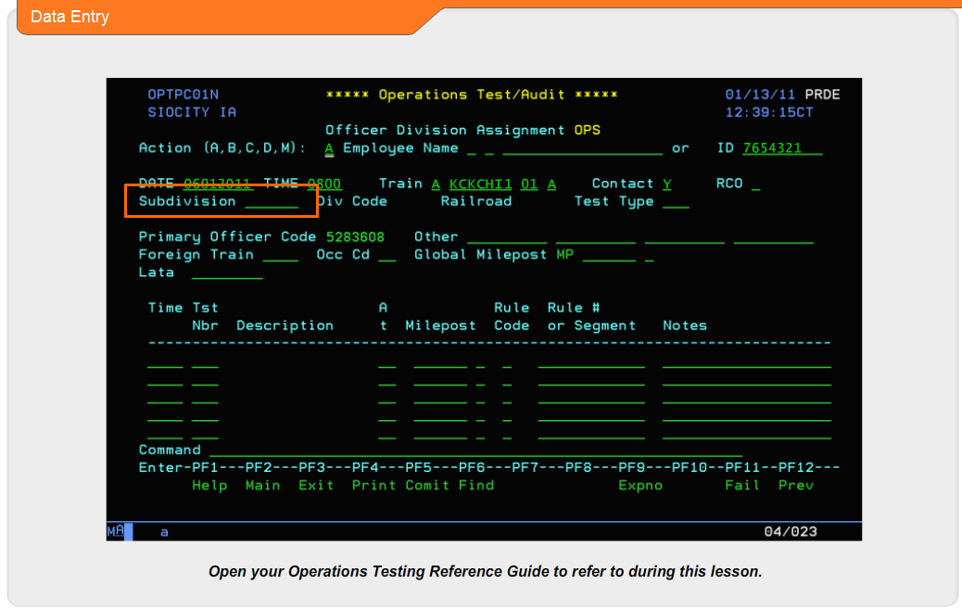
The Subdivision field is programmed to accept 6 alpha characters in the data entry field. If you are not sure of the 6 character code for the respected subdivision that you conducted the test on, use the F1 Help feature.
Once you have selected the correct code, enter that code in the Subdivision field.
After the Subdivision Code is entered, the DIV code and Railroad will be automatically entered.
The Test Type field is programmed to accept 3 alpha characters in the data entry field. If you are not sure of the 3 character code for the respective type of test that you conducted, use the F1 Help feature.
Once you have selected the correct code, enter that code in the Test Type field.
The Primary Officer Code field will have the employee number of the manager that is signed on to the computer.
In situations where more than one testing manager is involved in a testing event, up to four additional testing manager’s employee numbers can be added in the Other field.
The Foreign Train field will be used when entering test records for employees not employed by BNSF. We will review entering foreign and contract employees in another module.
The next field is for entering the tested employee’s Occupation Code [Occ Cd]. This field requires a two digit code to be entered. Again, the F1 Help feature will assist you in identifying specific occupation codes for the tested employee.
Global Milepost is the next field that we will need to populate with data. There are some interesting facts about global milepost that you need to understand. If you enter a milepost location in the global milepost field and then enter multiple test numbers, the global milepost entered will show for each test number. If you want to show different testing locations for each test entered, do not enter a global milepost.

Slide 9:
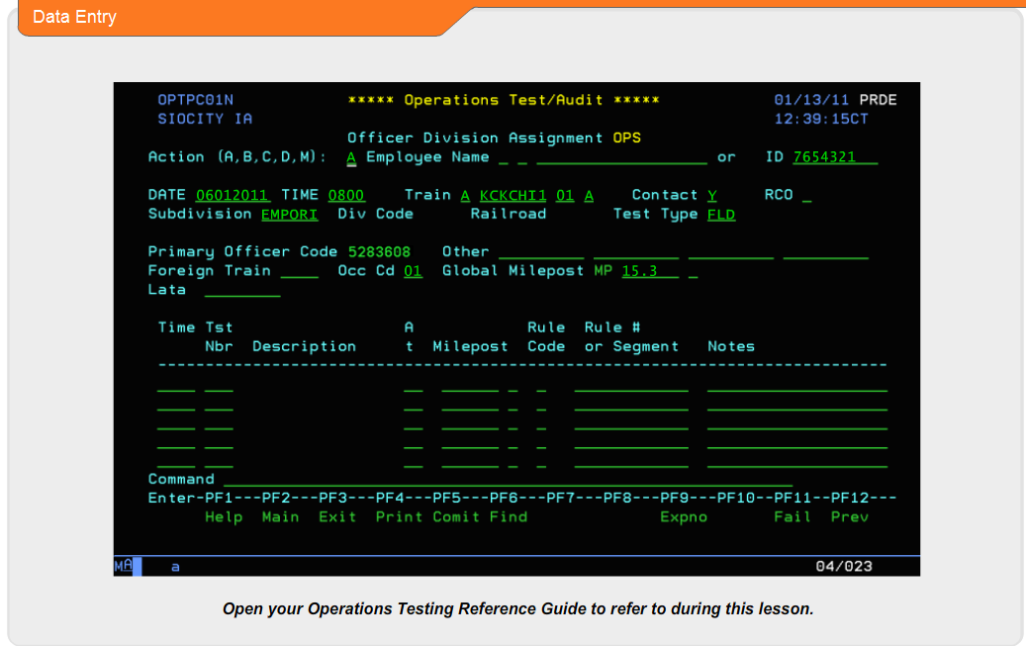
To enter the test number that corresponds to the test, or tests, that you conducted in the field, you will need to enter the 3 digit test number in the field labeled, Tst Nbr. We will enter a test number here.
We have now entered all the necessary information to properly record our field testing activities. At this point, press the Enter key.
The computer will now look up additional stored information and display in the testing Time, Descriptions field, and the Milepost.
If the test performed requires a Rule Code, and Rule #, or Segment, you will be prompted at this time to enter them.
Taking an overall look at the data entry for recording test, you can enter each test at the same time, and milepost, or manually enter each test with different times, and milepost.
Displayed at the bottom of the screen, in white font, you will find the words, “Press <PF5> for STORE/UPDATE”.
When you press the PF5 key, you will store your testing information into the computer system.
Slide 10:
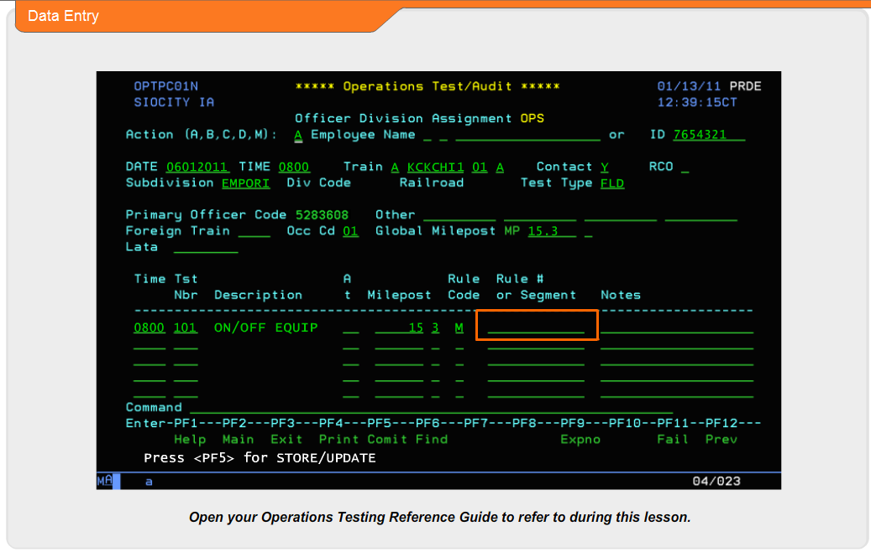
Certain tests require a specific Rule Book Code and Rule # to be entered in addition to the operations test number.
When this condition exists, you will be prompted if you have not already entered a specific Rule Book Code and Rule #.
The Lata entry position allows you to enter a Lata or LPE address to direct your testing data to a specific printer of your choice. After entering the additional required information, press the Enter key.

Slide 11:
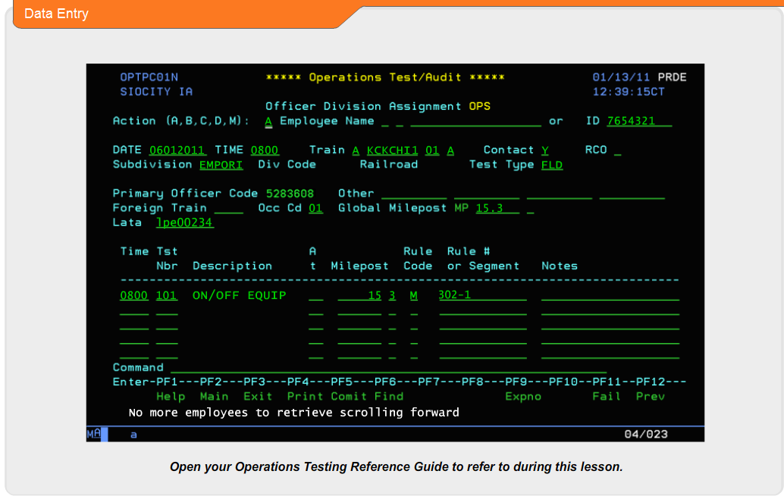
We have now successfully entered an operations test. At the bottom of the screen, you will see in white font text indicating that your print has been successfully printed.
The display will also indicate “No more employees to retrieve scrolling forward.”
If you did not select a printer address in the previous screen, the display at the bottom will simply say, “No more employees to retrieve scrolling forward.”
Additional tests may be entered using the same process we have just reviewed.
Always remember to ensure the accuracy of the testing information that you enter into the computer system. Validate that you have the correct employee for the specific job assignment that you are observing.
Make sure that your times, dates, and supporting test number information is correct. Consult the operations testing reference guide for test numbers that require sub-testing data entry.

Slide 12:
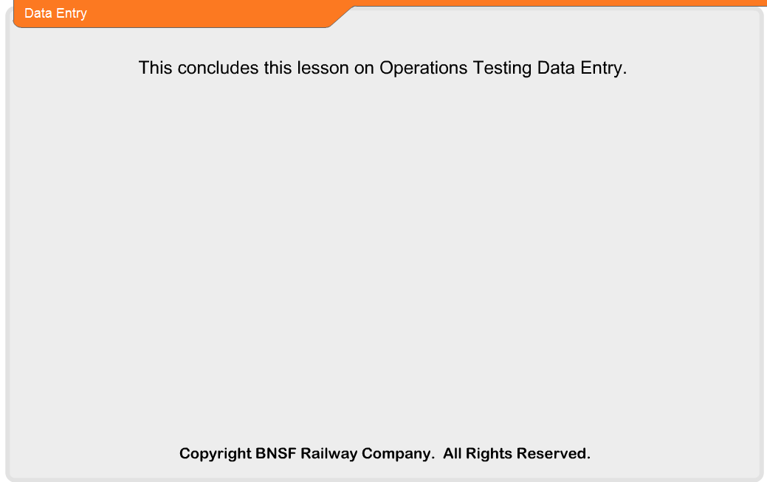
[No Audio] This concludes this lesson on Operations Testing Data Entry.

